

**ONLINE SHOPPING PLATFORM FOR STUDENTS, TEACHERS AT FPTU**

**Software Requirement Specification**

– HoChiMinh, September 2022 –

**Table of Contents**

I. Overview **3**

1. Introduction 3

2. System Functions 4

a. Screen Flow 4

b. Screen Details 4

c. User Authorization 5

d. Non-Screen Functions 7

3. Common Requirements 7

II. Functional Requirements **8**

1. <<Login>> 8

a. <<Login with google>> 8

b. <<Insert data into database>> 10

c. <<Divine role>> 11

2. <<Home page>> 12

a. <<Query product>> 12

b. <<Main banner, Icon>> 14

c. <<Category list>> 15

3. <<Search>> 15

a. <<Search by name>> 15

4. <<Sort>> 16

a. <<Sort product>> 16

5. <<Product detail>> 16

a. <<Product detail>> 16

6. <<Logout>> 19

a. <<Logout>> 19

7. <<Buy>> 20

a. <<Buy product>> 20

# I. Overview

## 1. Introduction

App "Online shopping platform for student, teachers at FPTU" was written to support the purchase and sale of all kinds of products by students and teachers at FPT University's Campuses via the internet.

"Online shopping platform for students, teachers at FPTU" is a new software system that replaces the current manual and telephone processes for buying and selling products. The system is expected to evolve over several releases, eventually connecting to the Internet buying and selling service for students and teachers of FPT University and being paid by e-wallets, products will be shipped by GHN.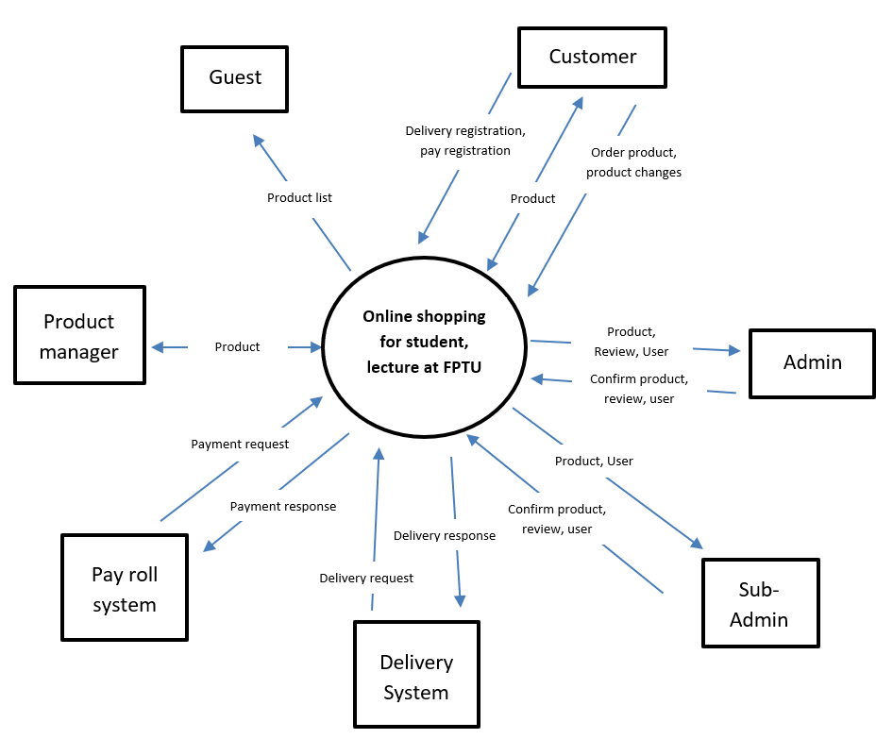

## 2. System Functions

#### a. Screen Flow

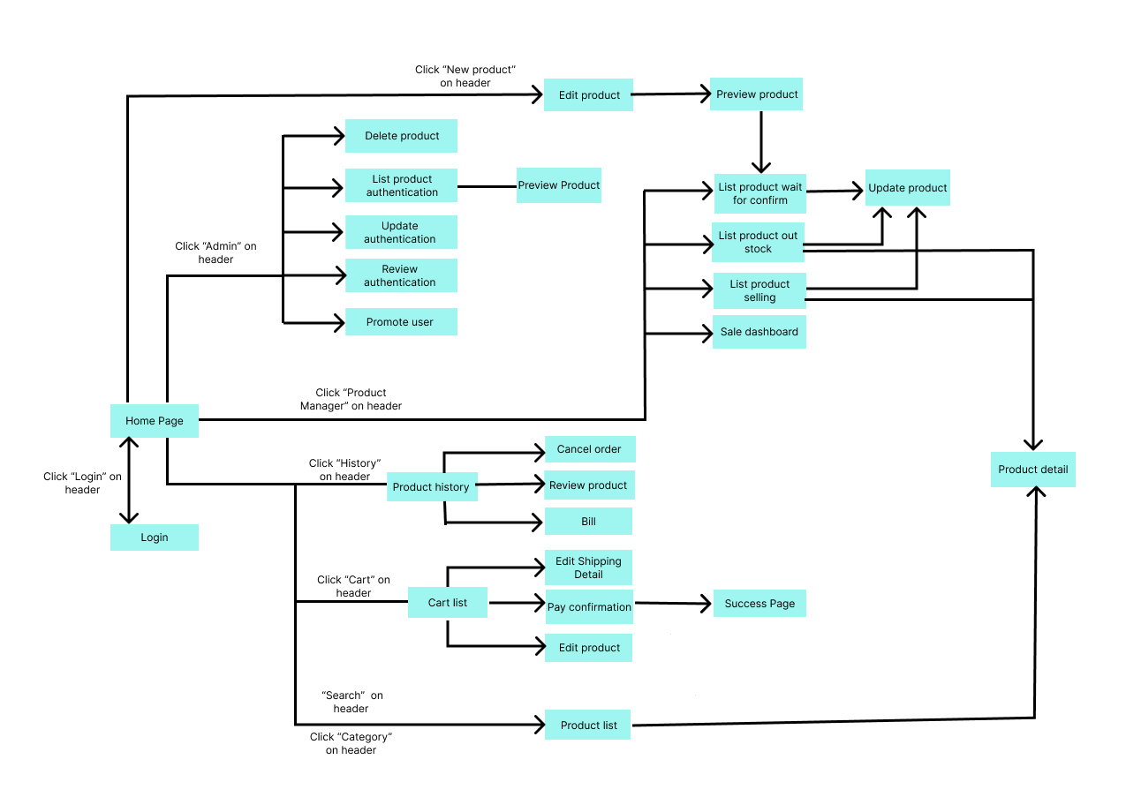

#### b. Screen Details

| **#** | **Feature** | **Screen** | **Description** |
| --- | --- | --- | --- |
| 1 | New Product | Create Product | Users insert new product information for sale on the app. |
| 2 | New Product | Preview Product | Users can change their product information. |
| 3 | Delete Product | Admin, Sub-Admin | Admin can delete products. |
| 4 | Product authentication | Admin, Sub-Admin | Admin approves the user's new product. |
| 5 | Update authentication | Admin, Sub-Admin | Admin approves user changes to product information. |
| 6 | Review authentication | Admin, Sub-Admin | Admin approve user reviews. |
| 7 | Promote, Demote user | Admin | Admins can promote users to admin or vice versa. |
| 8 | Login | Login | Login by email to buy products. |
| 9 | Search Product | Main | Search product. |
| 10 | Waiting for approves | Manager Product | Users can see their pending products. |
| 11 | Out stock Product | Manager Product | Users can see their sold out products. |
| 12 | Selling Product | Manager Product | Users can see the products they are selling. |
| 13 | DashBroad | Manager Product | Users can see the dashboard. |
| 14 | Update Product | Update Product | Users can update and delete their product. |
| 15 | History Product | History | Users can view their product purchase history. |
| 16 | Edit Cart | Cart | Users can add the products they want to buy to the cart. |
| 17 | Edit shipping | Shipping Information | Users can change and verify shipping information before order. |
| 18 | Order | Pay confirmation | Users can choose payment methods. |
| 19 | Admin dashboard | Admin, Sub-Admin | Statistics web. |
| 20 | Edit profile | User Information | Users can update their information. |

#### c. User Authorization

| **Screen** | **Guest** | **Customer** | **Sub-Admin** | **Admin** | **Bought Product** |
| --- | --- | --- | --- | --- | --- |
| <<Screen Login>> | x | x | x | x | x |
| Login Email FPT | x | x | x | x | x |
|  |  |  |  |  |  |
| <<Screen Main>> | x | x | x | x | x |
| Search Product | x | x | x | x | x |
| Query Category List | x | x | x | x | x |
| Query Best Seller Product | x | x | x | x | x |
| Query New Product | x | x | x | x | x |
| Product Page Information | x | x | x | x | x |
| Banener |  |  |  |  |  |
|  |  |  |  |  |  |
| <<Screen Product Information>> | x | x | x | x | x |
| View Seller Information | x | x | x | x | x |
| Buy Product |  | x | x | x | x |
| Review Product |  | x | x | x | x |
| Seller’s Product |  |  |  |  |  |
| Product Detail |  |  |  |  |  |
|  |  |  |  |  |  |
| <<Screen Cart>> |  | x | x | x | x |
| List Items |  | x | x | x | x |
| Pay Confirmation |  | x | x | x | x |
| Delete Product |  | x | x | x | x |
| Adjust Product Quantity |  | x | x | x | x |
| Update Information For Shipping |  | x | x | x | x |
| Query Shipping Information |  | x | x | x | x |
| Select buy product |  |  |  |  |  |
|  |  |  |  |  |  |
| <<Screen Pay>> |  | x | x | x | x |
| Update Information For Shipping |  | x | x | x | x |
| Query Shipping Information |  | x | x | x | x |
| Insert Information Payment |  | x | x | x | x |
| Insert Information For Shipping |  | x | x | x | x |
| Payment |  | x | x | x | x |
|  |  |  |  |  |  |
| <<Screen Bill>> |  | x | x | x | x |
| Show Bill |  | x | x | x | x |
| Query Cancel Order |  | x | x | x | x |
| Query Confirm Cancel Order |  | x | x | x | x |
| Return HomePage |  | x | x | x | x |
|  |  |  |  |  |  |
| <<Screen Upload New Product>> |  | x | x | x | x |
| Upload Image |  | x | x | x | x |
| Upload Category |  | x | x | x | x |
| Upload Product Name |  | x | x | x | x |
| Upload Price |  | x | x | x | x |
| Insert Product Detail |  | x | x | x | x |
| Upload Seller Information |  | x | x | x | x |
| Send Request Product Authenticate |  | x | x | x | x |
| Preview Product Detail |  | x | x | x | x |
|  |  |  |  |  |  |
| <<Screen User Information>> |  | x | x | x | x |
| Insert User Information |  | x | x | x | x |
| Insert Update Information |  | x | x | x | x |
| Query User Information |  | x | x | x | x |
|  |  |  |  |  |  |
| <<Screen User Buy>> |  | x | x | x | x |
| Query All Ordered Product |  | x | x | x | x |
| Select Bill Detail |  | x | x | x | x |
|  |  |  |  |  |  |
| <<Screen Selling Product>> |  | x | x | x | x |
| Query All Selling Product |  | x | x | x | x |
| Query Out Stock |  | x | x | x | x |
| Pending Product Authentication |  | x | x | x | x |
| Dashboard |  | x | x | x | x |
| Delete Product Selling |  | x | x | x | x |
| Update Product Selling |  | x | x | x | x |
| Confirm Delete Product Selling |  | x | x | x | x |
|  |  |  |  |  |  |
| << Screen Out of Stock Product >> |  | x | x | x | x |
| Delete Product Selling |  | x | x | x | x |
| Update Product Selling |  | x | x | x | x |
| Confirm Delete Product Selling |  | x | x | x | x |
|  |  |  |  |  |  |
| <<Pending Product Authentication >> |  | x | x | x | x |
| Delete Product Selling |  | x | x | x | x |
| Update Product Selling |  | x | x | x | x |
| Confirm Delete Product Selling |  | x | x | x | x |
|  |  |  |  |  |  |
| <<Screen Review Product>> |  |  |  |  |  |
| Insert Review Product |  |  |  |  |  |
|  |  |  |  |  |  |
| <<Screen Admin>> |  |  |  | x |  |
| Search User |  |  |  | x |  |
| Query User List |  |  |  | x |  |
| Demote Sub Admin |  |  |  | x |  |
| Promote User to Sub Admin |  |  |  | x |  |
| Confirm New Product |  |  |  | x |  |
| Confirm Review |  |  |  | x |  |
| Confirm Update Product Information |  |  |  | x |  |
| Query All Product |  |  |  | x |  |
| Delete Product |  |  |  | x |  |
| Confirm Delete Product |  |  |  | x |  |
|  |  |  |  |  |  |
| <<Screen Sub Admin>> |  |  | x | x |  |
| Confirm New Product |  |  | x | x |  |
| Confirm Review |  |  | x | x |  |
| Confirm Update Product Information |  |  | x | x |  |
| Query All Product |  |  | x | x |  |
| Delete Product |  |  | x | x |  |
| Confirm Delete Product |  |  | x | x |  |
|  |  |  |  |  |  |

#### d. Non-Screen Functions

| **#** | **Feature** | **System Function** | **Description** |
| --- | --- | --- | --- |
| 1 | New Product | createProduct | Insert new product information into database. |
| 2 | Add Cart | addCart | Insert or update products in the cart into the database. |
| 3 | Delete Product | deleteProduct | Delete product in database. |
| 4 | Product authentication | updateProduct | Update product in database. |
| 5 | Updata authentication | checkProduct | Update status product in database. |
| 6 | Review authentication | checkReview | Update user reviews to database. |
| 7 | Promote, Demote user | updateRole | Update role of user in database. |
| 8 | Edit Cart | updateCart | Update information of product in cart into database |
| 9 | Edit shipping | updateShipping | Update shipping Information in database |
| 10 | Order | payConfirmation | Insert payment method into database |
| 11 | Edit profile | updateProfile | Update information of user in database |
| 12 | Pay | payment | Send information to sandbox environment |
| 13 | Payed | updateOrder | Update status of order and insert order date, address, ward, district, city when payed into database |
| 14 | Delivered | updateOrderDelivered | Update Shipped date into database |

## 

## 3. Common Requirements

* Create an online store for FPTU students, teachers and staff.
* Users can upload a new product for sale.
* Main page should have top seller products and new products.
* Admin must approve products for sale.
* Admin must approve reviews for the product.
* Admin can promote and demote user roles.
* Seller should have a page for controlling the product.
* Users can check order history.
* Users can update their information.
* Sellers should be able to preview their product before submitting.
* Users should be able to cancel their order.
* Users should be able to update their product information.
* Users must login by FPT email.

# II. Functional Requirements

## 1. <<Login>>

### a. <<Login with google>>

* Function trigger: click on login in header - forward to login page - click on google login icon - login google page
* Function description: for login to know the role of user and user information, allow users to buy product and update information.
* Screen layout:
  + Login Form

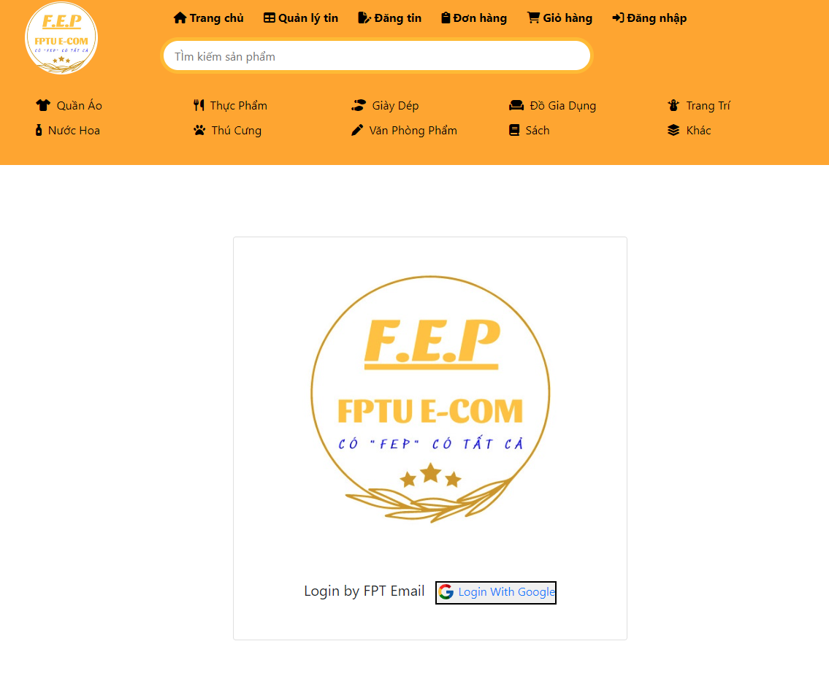

* + Google Form

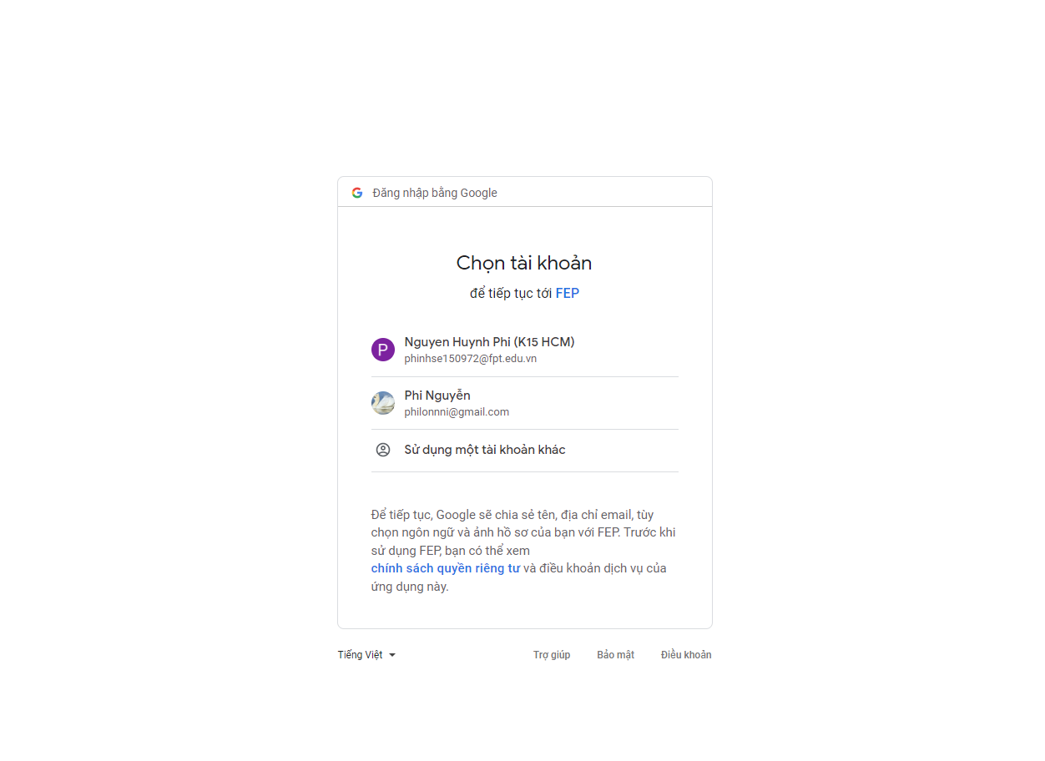

* + Login failed

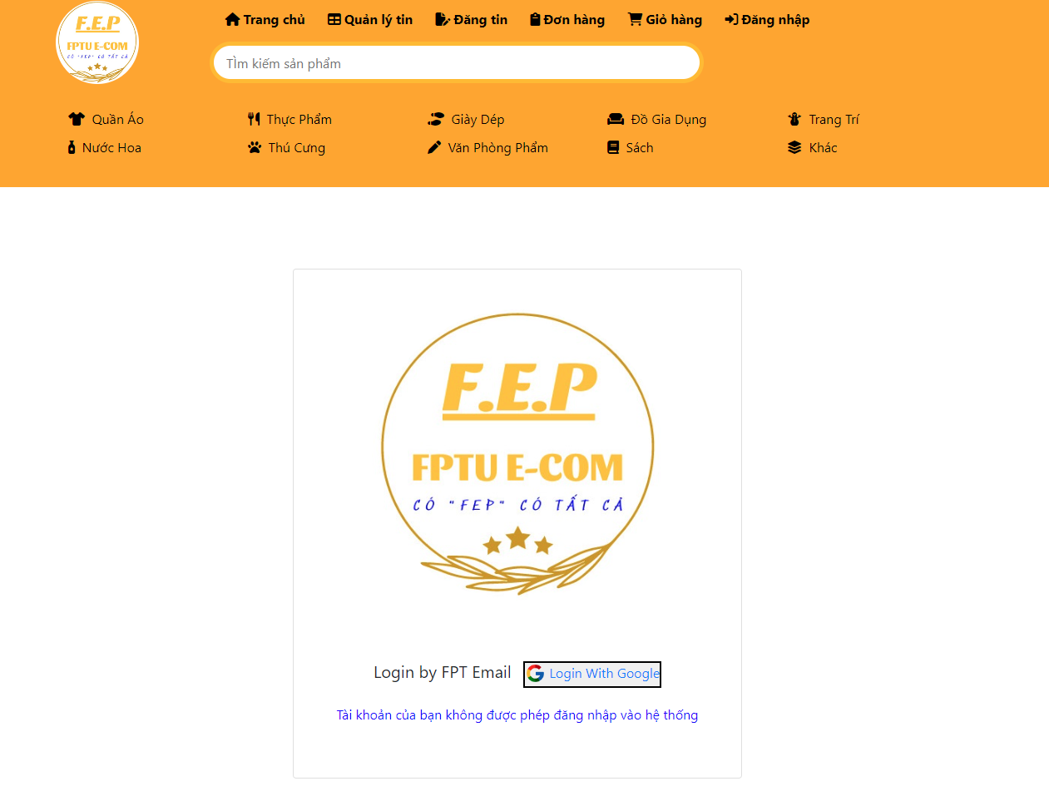

* Function Details: login allows users to know their role and information. when user login the user will forward to the google login page. If login success (correct account and email is a FPT mail) they will be forwarded to main page order while they need to login again with an FPT account.

### b. <<Insert data into database>>

* Function trigger: After login success user data will be added to the database.
* Function description: for web know role, information of user and allow user to update information.
* Screen layout:

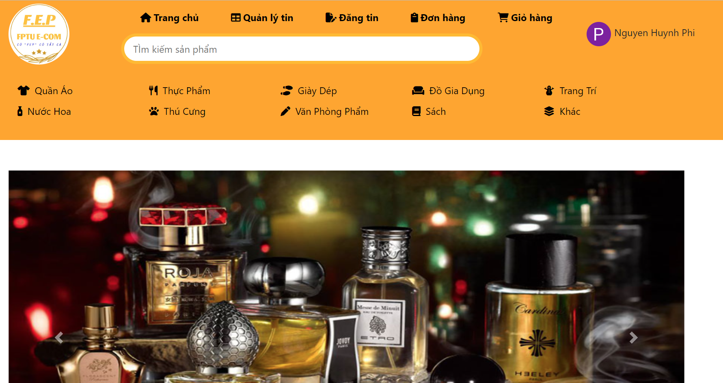

* Function Details: After login successfully user data will be added to the database and forward to main with user role, avatar.

### 

### 

### c. <<Divine role>>

* Function trigger: After login success the web will divine the role of the user.
* Function description: for web know role (admin, user, sub-admin) of user and allow user to special work by creating a session.
* Screen layout:
  + User Layout.



* + Admin Layout.

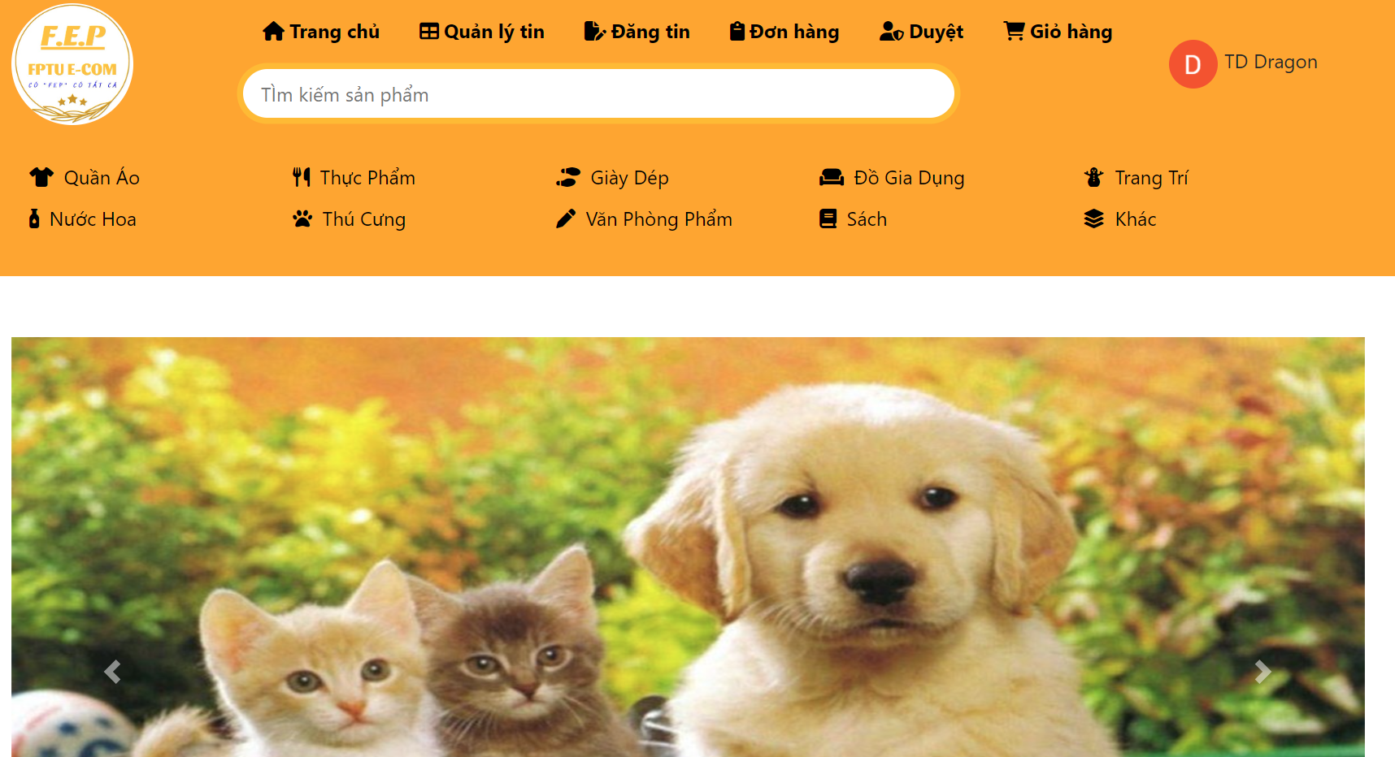

* Function Details: After login successfully user data will be divined on role. If user it will allow to update information, If admin and sub amin it allow to promote product, review, delete product. Admin will be allowed to promote users to admin.

## 

## 2. <<Home page>>

### a. <<Query product>>

* Function trigger: start up the web page or click on the main Page.
* Function description: Select product (best seller product, new product).
* Screen layout:

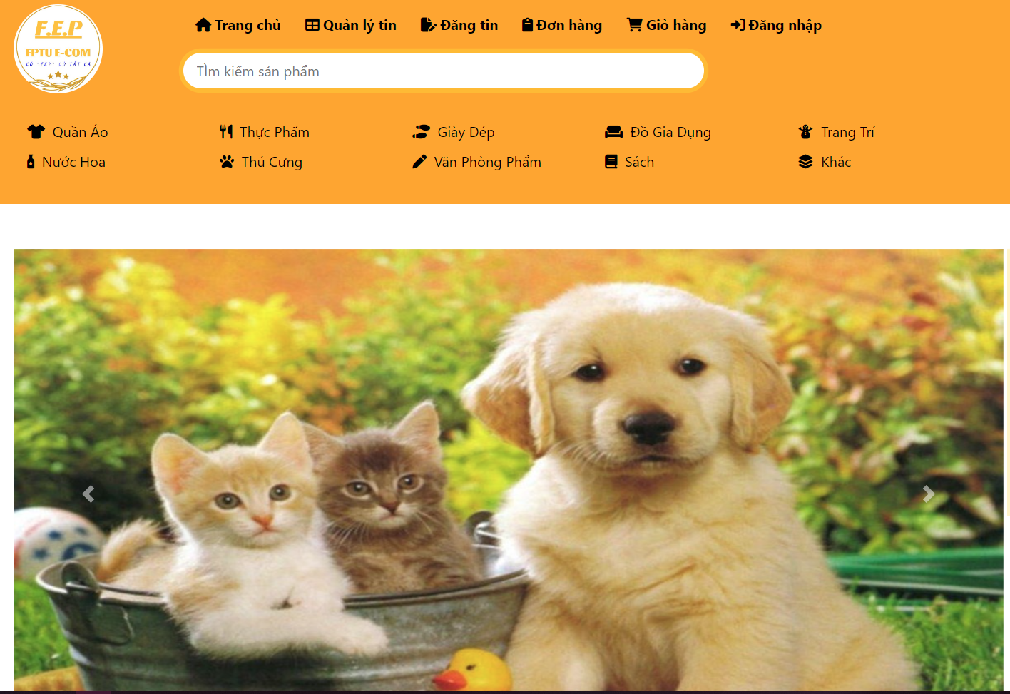

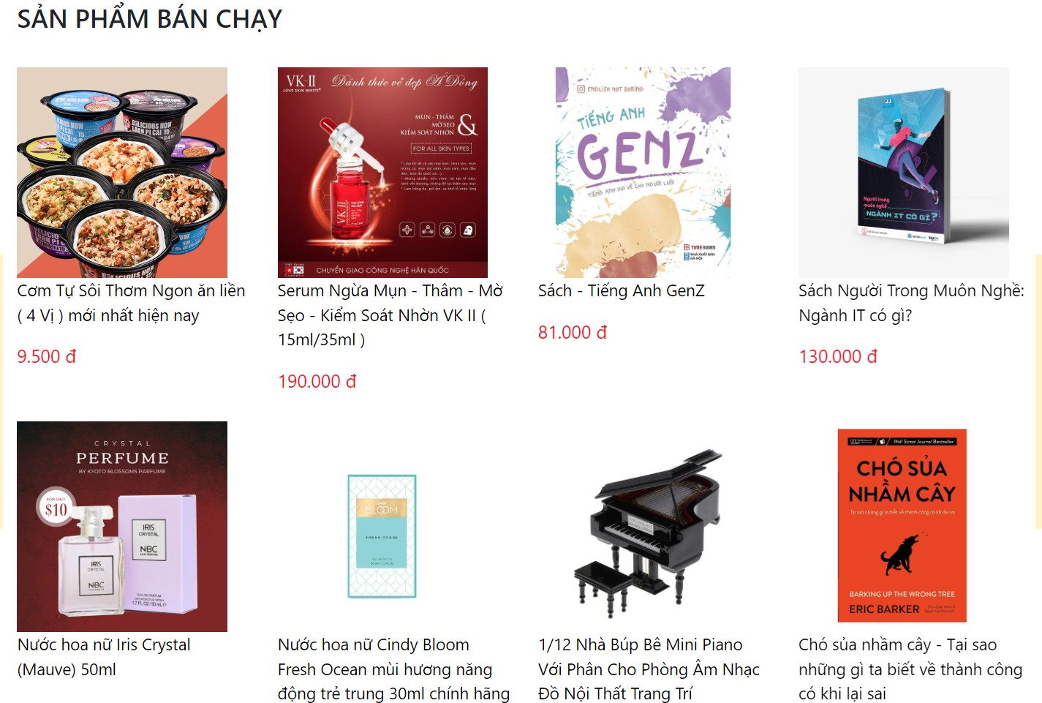

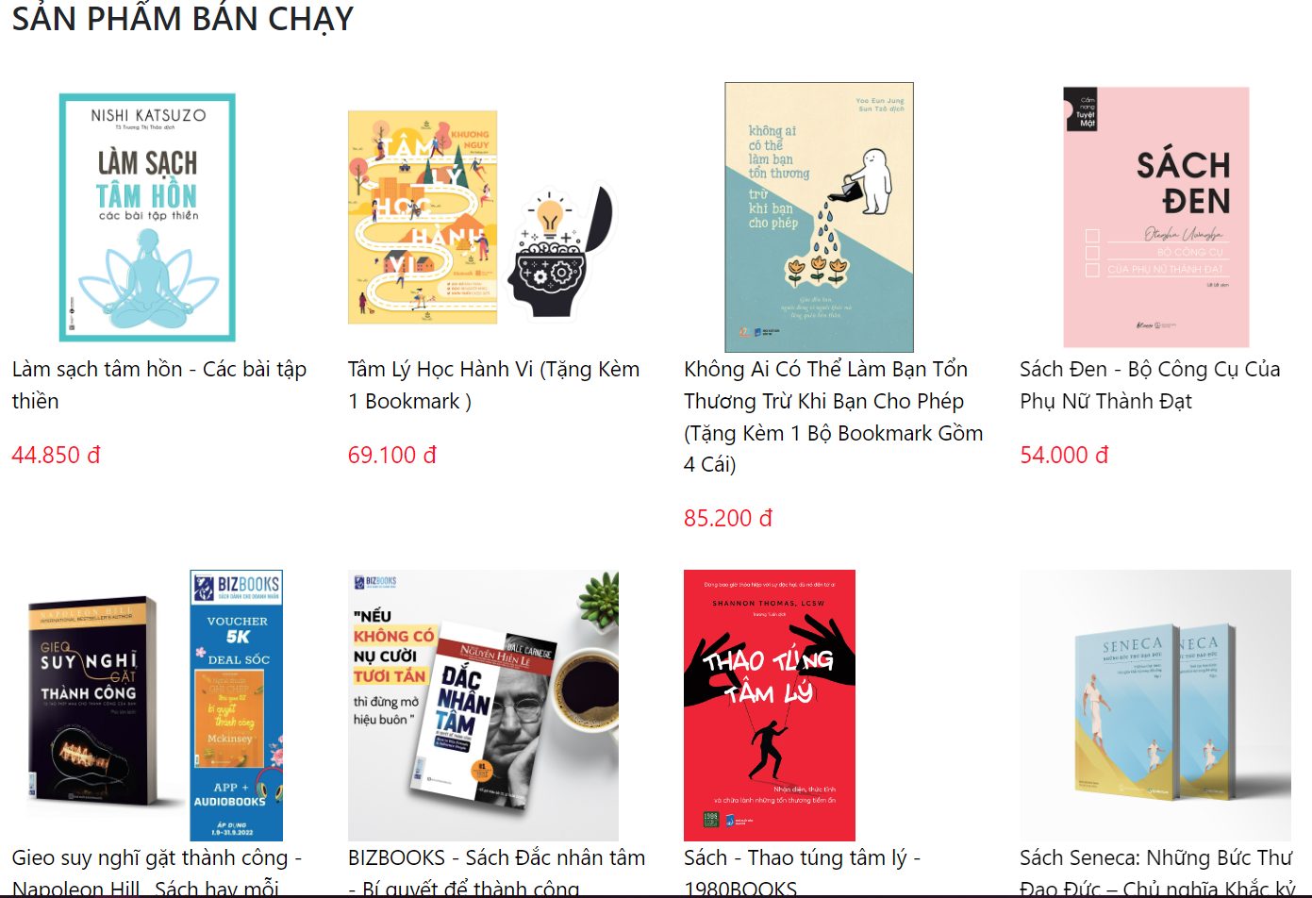

* Function Details: Select product information from database and print out on the main page.

### 

### 

### b. <<Main banner, Icon>>

* Function trigger: start up the web page or click on the main page.
* Function description: Select banner (main banner, slide banner right, left), Icon (Facebook, Instagram, Youtube).
* Screen layout:
  + Banner



* + Icon



* Function Details: Select banner (main banner, slide banner right, left), icon on footer, create a link for a banner and Icon for user to click-in, if click on banner it will forward to a sort by category, if click on icon it will forward to Facebook, Instagram, Youtube.

### 

### c. <<Category list>>

* Function trigger: on header (load web).
* Function description: Select category on database.
* Screen layout:

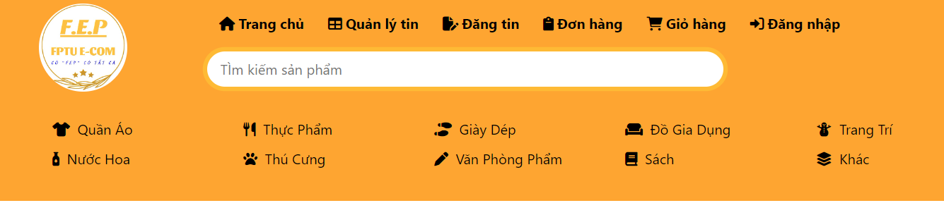

* Function Details: Select category list from database and print out on the header page, when clicking on category on header it will forward to product list sort by category.

## 

## 3. <<Search>>

### a. <<Search by name>>

* Function trigger: searching on the search bar on header.
* Function description: search product by name for use.
* Screen layout:

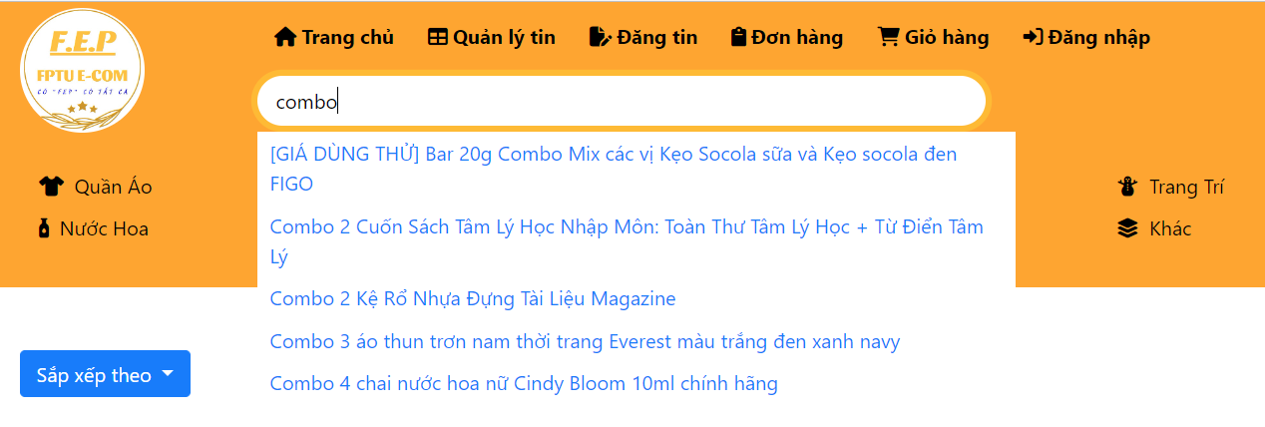

* Function Details: Select product list from database by searching name and print out on product list page, when clicking on product it forward to product detail.

## 4. <<Sort>>

### a. <<Sort product>>

* Function trigger: click on sort option (category, name, price, unit sell, new product).
* Function description: sort product by (category, name, price, unit sell, new product) sort product for user to easier to choose the product they needed to buy.
* Screen layout:

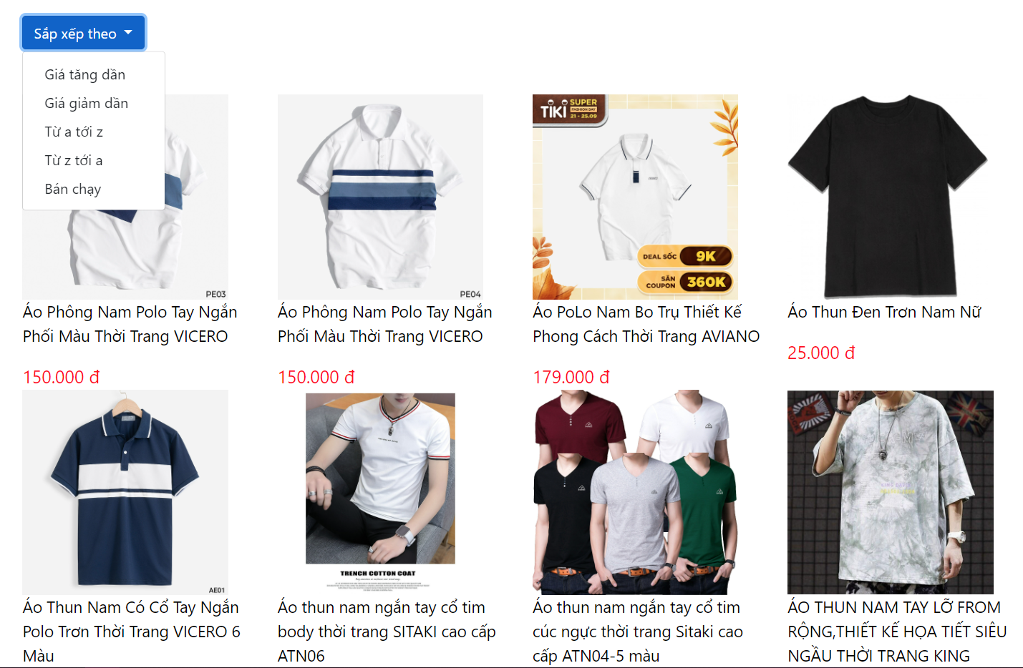

* Function Details: Select product list from database by sort option.

## 5. <<Product detail>>

### a. <<Product detail>>

* Function trigger: click on product, it shows the product information (product detail, product review, product, list seller's products).
* Function description: show the product information for use to preview the product and select the product to buy.
* Screen layout:

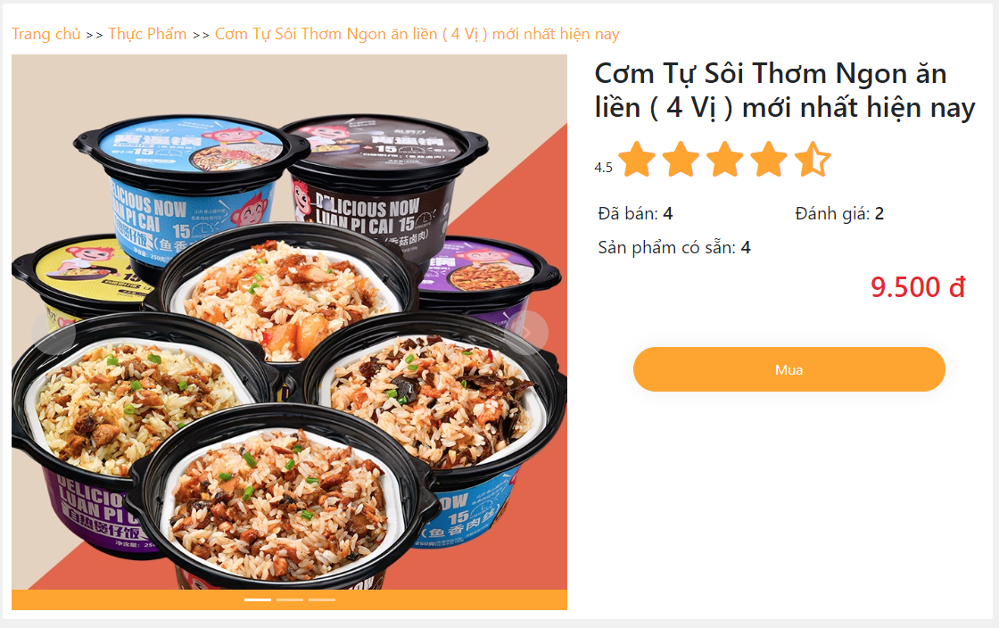



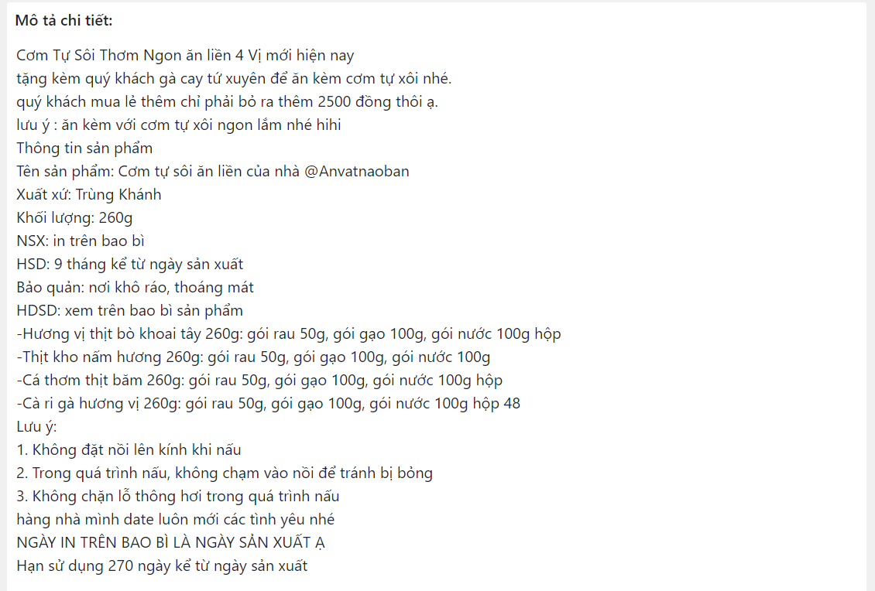

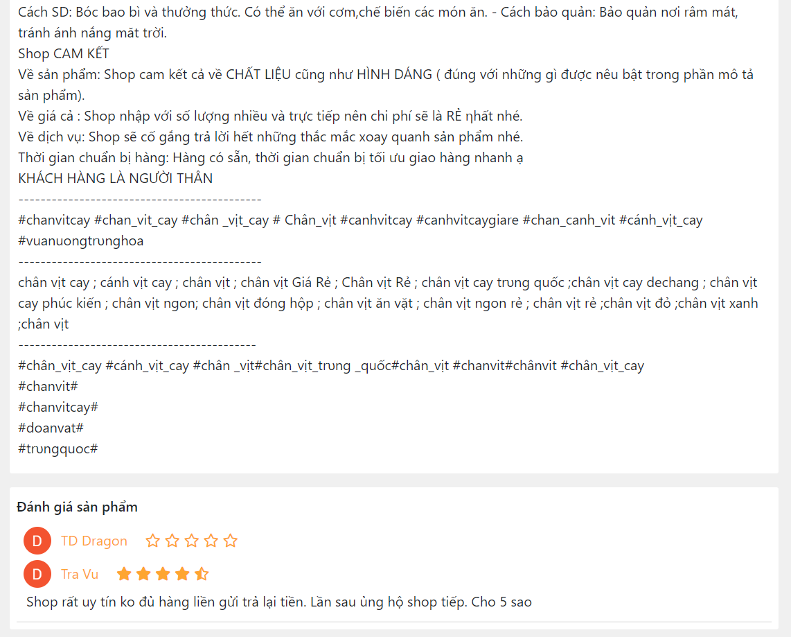

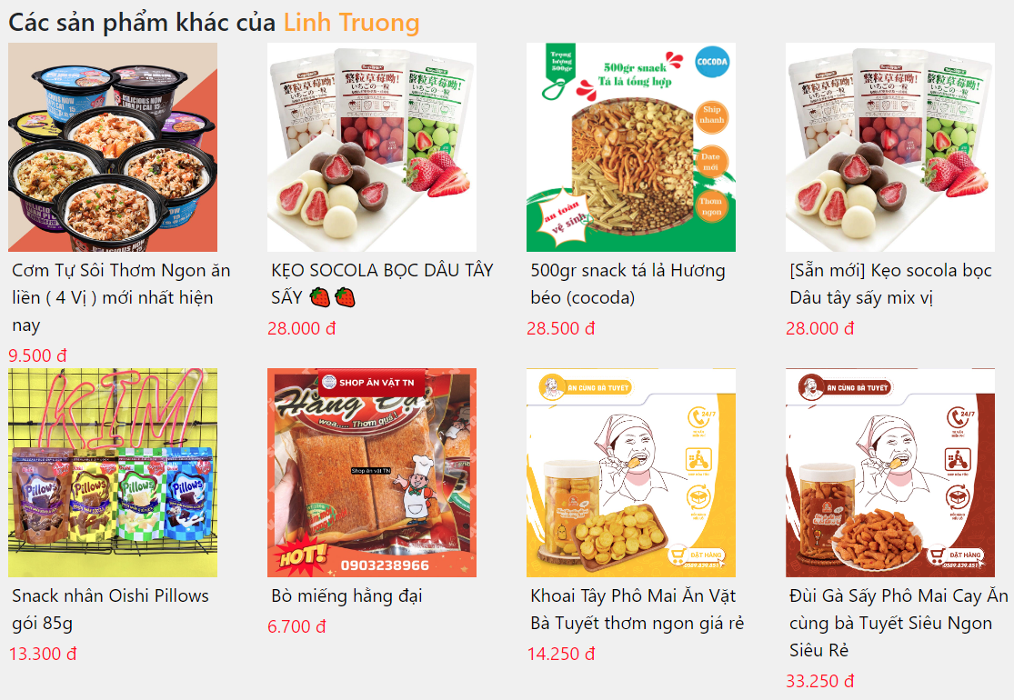

* Function Details: when a user clicks on the product on the product list it will send to the product detail page it will show (product detail, product review, product, list seller's products) for user to preview and buy the product.

## 6. <<Logout>>

### a. <<Logout>>

* Function trigger: click on logout on avatar user.
* Function description: it will logout a user account and show the login option on header.
* Screen layout:

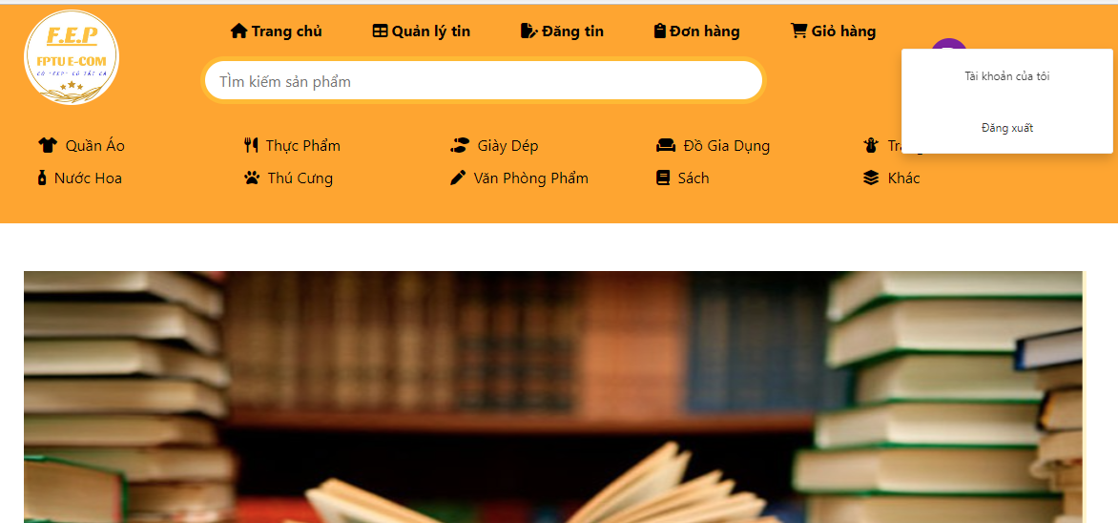

* Function Details: when a user clicks on the logout function on the avatar (user logged) it will logout (clear session) and hide special work (admin, update user information) for role and show the login option on header.

## 7. <<Buy>>

### a. <<Buy product>>

* Function trigger: click on option buy on product detail.
* Function description: Allow users to add product to cart for buy.
* Screen layout:



* Function Details: when a user clicks on the buy option on product detail the web will check the login. If user logged It will allow the user to add product to cart, if user has not logged it forward to the login page for user to login.

### 

### 

### 